**Finding Resistance by Color Coding method**



**Submitted to**

**HASEEN ULLAH JAN**

**NAME MUHAMMAD SADEEQ**

**ROLL NO 75025**

**REG NO 21PWCSE2028**

**SECTION C**

**Department of Computer System Engineering**

**University of Engineering and Technology Peshawar**

**Pakistan**

**Feb 2022**

**Theory**

Resistor values are marked onto the body of the resistor using a series of color bands. These give the value of the resistor as well as other information including the tolerance. The band closest to the end of the resistor body is taken to the Band NO 1.

In case of four color bands, the first two bands are significant figures of values, the third band is a multiplier (number of zeros) and fourth band is tolerance band.

**Apparatus:**

Following apparatus are needed to carry out this verification:

1. Different resistors with color bands.
2. Ohm meter i.e. Multimeter.

****Diagram:**

**Procedure:**

The resistance of a given resistor can be found by following method:

1. First band will give tens number in numerical value of the resistance.
2. Second band will give unit number in numerical value of resistance.
3. Third band gives the value of in numerical multiple of ten for the first value.
4. Fourth band gives the resistance tolerance.

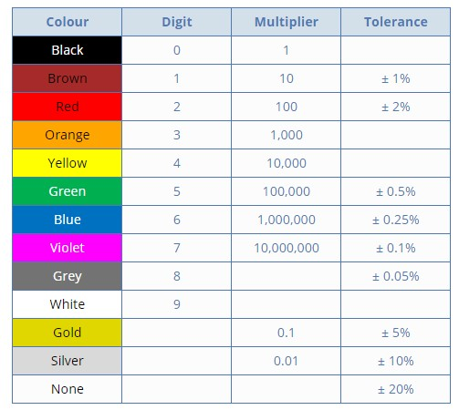

**Readings:**

|  |  |  |  |  |  |  |  |
| --- | --- | --- | --- | --- | --- | --- | --- |
| S.NO | 1ST band | 2nd band | 3rd band | 4th band | Resistance  Ω | Resistance of ohm meter Ω | Error |
| 1 | 2 | 2 | 101 | ±5% | 22x101±5% | 21.7x101 | 0 |
| 2 | 1 | 5 | 103 | ±5% | 15x103±5% | 14.3x103 | 0 |
| 3 | 4 | 7 | 103 | ±5% | 47x103±5% | 0.7 | 0.206 |
| 4 | 6 | 8 | 101 | ±5% | 68x101±5% | 6.9 | 0 |
| 5 | 4 | 3 | 102 | ±5% | 43x102±5% | 4.25k | 0 |
| 6 | 1 | 0 | 107 | ±5% | 1x107±5% | 9.62M | 0 |
| 7 | 1 | 0 | 105 | ±5% | 1x105±5% | 0.956M | 0 |